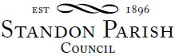
Parish Council Meeting
!!This is a remote meeting on Zoom!!!
Monday 8th March 2021 - 7.30pm

AGENDA

- Public session:

- To receive and consider any apologies for absence

- To receive any Declarations of Interest in accordance with Standon Parish Council Code of Conduct (2007)

- Vacancy for a Parish Councillor

- Minutes: To approve the minutes of the meeting of 11th January 2021 and consider matters arising.

- Planning
- To report on Planning decisions
- To report on new Applications
- To discuss current Planning Applications and confirm responses.

- Finance
- To receive a report on the Accounts for the year to date
- To approve accounts for payment
- To discuss applications for financial support

- Highways

- Special Items
- Parish Projects: Short and long term programme.

- To receive and consider items of correspondence

- Items raised by Councillors for information or inclusion on agenda for next meeting.

- To confirm the Date and Venue of Next Parish Council Meeting.

Monday 10th May 2021, Annual Parish Meeting followed by the Annual Parish Council meeting, 7.30 pm at All Saints School, Standon or if necessary remotely using Zoom

This is a public meeting. the details for connecting on-line are given below.
https://us02web.zoom.us/j/85993976666?pwd=MDcwL0JLQVNhNGptbFk4OXNpelkvQT09

Meeting ID: 859 9397 6666 Passcode: 503061

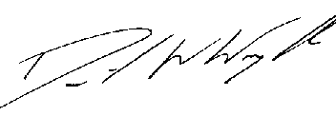
Clerk: D W Wright
The Garth
2 Broc Hill Way
Milford
Stafford, ST17 0UB
Tel: 01785 661182
1st March 2021 standonpcclerk@yahoo.co.uk

www.standonparish.org.uk

