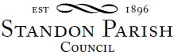
Parish Council Meeting
All Saints School, Standon
Monday 10th July 2023 - 7.30pm

AGENDA

- Public session:

- To receive and consider any apologies for absence

- To receive any Declarations of Interest in accordance with Standon Parish Council Code of Conduct (2007)

- To appoint a Chairman and Vice Chairman

- Casual Vacancy. To co-opt Parish Councillors

- Minutes: To approve the minutes of the meeting of 13th May 2023 and consider matters arising.

- Finance
- To receive a report on the Accounts for the year to date
- To approve accounts for payment
- To discuss applications for financial support

- Planning
- To report on Planning decisions
- To report on new Applications
- To discuss current Planning Applications and confirm responses.

- Highways

- Special Items
- Parish Projects: Short and long term programme.

- To receive and consider items of correspondence

- Items raised by Councillors for information or inclusion on agenda for next meeting

- To confirm the Date and Venue of Next Parish Council Meeting.

Monday 11th September 2023, 7.30 pm at Cotes Heath & Standon Community Centre.

This is a PUBLIC meeting and you are invited to attend.
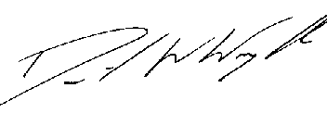
Clerk: D W Wright
The Garth
2 Broc Hill Way
Milford
Stafford, ST17 0UB
Tel: 01785 661182
3rd July 2023 standonpcclerk@yahoo.co.uk
www.standonparish.org.uk

