NOTICE OF MEETING

STANDON PARISH COUNCIL

Parish Council Meeting
All Saints School, Standon.
Monday 11th September 2017 - 7.30pm

AGENDA

- Public session:

- To receive and consider any apologies for absence

- To receive any Declarations of Interest in accordance with Standon Parish Council Code of Conduct (2007)

- Minutes: To approve the minutes of the meeting of 10th July 2017 and consider matters arising.

- Planning
- To report on Planning decisions
- To report on new Applications
- To discuss current Planning Applications and confirm responses.

- Finance
- To receive a report on the Accounts for the year to date
- To approve accounts for payment

- Special Items
- Parish Projects: Short and long term programme.

- To receive and consider items of correspondence

- Items raised by Councillors for information or inclusion on agenda for next meeting

- To confirm the Date and Venue of Next Parish Council Meeting.

Monday 13th November 2017, 7.30 pm at Cotes Heath & Standon Village Hall

This is a PUBLIC meeting and you are invited to attend.
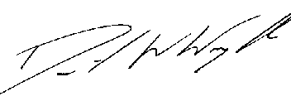
Clerk: D W Wright
The Garth
2 Broc Hill Way
Milford
Stafford, ST17 0UB
3rd September 2017 standonpcclerk@yahoo.co.uk

