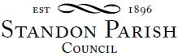
Parish Council Meeting
!!This is a remote meeting on Zoom!!!
Monday 11th January 2021 - 7.30pm

AGENDA

- Public session:

- To receive and consider any apologies for absence

- To receive any Declarations of Interest in accordance with Standon Parish Council Code of Conduct (2007)

- Co-option to fill a Vacancy for a Parish Councillor

- Minutes: To approve the minutes of the meeting of 9th November 2020 and consider matters arising.

- Planning
- To report on Planning decisions
- To report on new Applications
- To discuss current Planning Applications and confirm responses.

- Finance
- To receive a report on the Accounts for the year to date
- To approve accounts for payment
- To discuss a budget and set the Precept for 2021/22

- Highways

- Special Items
- Parish Projects: Short and long term programme.

- To receive and consider items of correspondence

- Items raised by Councillors for information or inclusion on agenda for next meeting.

- To confirm the Date and Venue of Next Parish Council Meeting.

Monday 8th March 2021, 7.30 pm at Cotes Heath & Standon Community Centre or if necessary remotely using Zoom

This is a public meeting. the details for connecting on-line are given below.
https://us02web.zoom.us/j/83154525841?pwd=nwovr3jqq2twadllsgnirjd5agq5qt09

Meeting id: 831 5452 5841 Passcode: 121245
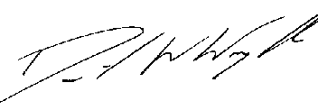
Clerk: D W Wright
The Garth
2 Broc Hill Way
Milford
Stafford, ST17 0UB
Tel: 01785 661182
2nd January 2021 standonpcclerk@yahoo.co.uk

www.standonparish.org.uk

