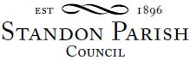
Parish Council Meeting
Cotes Heath & Standon Community Centre
Monday 11th July 2022 - 7.30pm

AGENDA

- Public session:

- To receive and consider any apologies for absence

- To receive any Declarations of Interest in accordance with Standon Parish Council Code of Conduct (2007)

- Casual Vacancy for a {Parish Councillor

- Minutes: To approve the minutes of the meeting of 16th May 2022 and consider matters arising.

- Planning
- To report on Planning decisions
- To report on new Applications
- To discuss current Planning Applications and confirm responses.

- Finance
- To receive a report on the Accounts for the year to date
- To approve accounts for payment

- Highways

- Special Items
- Parish Projects: Short and long term programme.

- To receive and consider items of correspondence

- Items raised by Councillors for information or inclusion on agenda for next meeting

- To confirm the Date and Venue of Next Parish Council Meeting.

Monday 12th September 2022, , 7.30 pm at All Saints School, Standon

This is a PUBLIC meeting and you are invited to attend.
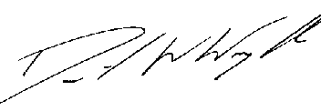
Clerk: D W Wright
The Garth
2 Broc Hill Way
Milford
Stafford, ST17 0UB
Tel: 01785 661182
4th July 2022 standonpcclerk@yahoo.co.uk

www.standonparish.org.uk

