STANDON PARISH COUNCIL

Clerk: D W Wright
The Garth ,2 Broc Hill Way
Milford
Stafford, ST17 0UB
Tel: 01785 661182
standonpcclerk@yahoo.co.uk

ANNUAL PARISH ASSEMBLY

The annual parish assembly of the Standon Parish will be held on Monday 14th May 2018 at 7.30pm at Cotes Heath & Standon Community Centre, Cotes Heath

AGENDA

- Apologies
- Minutes of last Parish Meeting 8th May 2017
- Chairman’s Report
- Accounts of The Parish Council
- Items for discussion raised by electors
  - New projects for the Parish

This meeting will be followed by the ANNUAL PARISH COUNCIL MEETING

This is a PUBLIC meeting and you are urged to attend and participate !!

Signed:
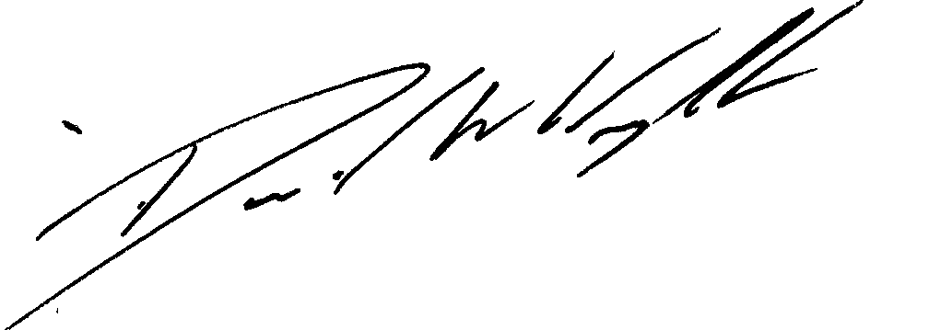

Clerk

7th May 2018

!!! Parish Website is live at www.standonparish.org.uk !!!

