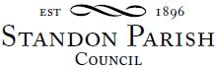

Clerk: D W Wright
The Garth ,2 Broc Hill Way
Milford
Stafford, ST17 0UB
Tel: 01785 661182
standonpcclerk@yahoo.co.uk

ANNUAL PARISH ASSEMBLY

The annual parish assembly of the Standon Parish will be held on Monday 10th May 2021 at 7.30pm.

!!This is a remote meeting on Zoom!!!

AGENDA

- Apologies
- Minutes of last Parish Meeting 11th May 2020
- Chairman’s Report
- Accounts of The Parish Council
- Items for discussion raised by electors
  - New projects for the Parish

This meeting will be followed by the ANNUAL PARISH COUNCIL MEETING

This is a PUBLIC meeting and you are invited to attend.
The details for connecting on-line are below. https://us02web.zoom.us/j/83403313658?pwd=WW1aNTEyQUR2dWgzVXhXeVZpcm5EZz09

Meeting ID: 834 0331 3658 Passcode: 552382

Signed:
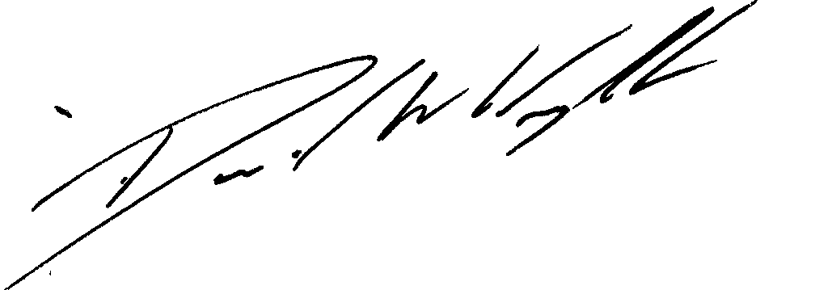

Clerk

3rd May 2021

