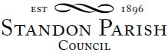

Parish Council Meeting

Monday 4th October 2021 – 7.30pm
Cotes Heath & Standon Community Centre
AGENDA

- Public session:

- To receive and consider any apologies for absence

- To receive any Declarations of Interest in accordance with Standon Parish Council Code of Conduct (2012)

- Minutes: To approve the minutes of the meeting of 12th July 2021 and consider matters arising.

- Environment – Highways and Flooding Control

- Planning
- To report on Planning decisions
- To report on new Applications
- To discuss current Planning Applications and confirm responses.

- Finance
- To receive a report on the Accounts for the year to date
- To approve accounts for payment

- Special Items
- Parish Projects: Short and long term programme.

- To receive and consider items of correspondence

- Items raised by Councillors for information or inclusion on agenda for next meeting

- To confirm the date and venue of the next Parish Council meeting

Monday 9th November 2021, 7.30 pm at Cotes Heath & Standon Community Centre, Station Road, Cotes Heath

This is a PUBLIC meeting and you are invited to attend.

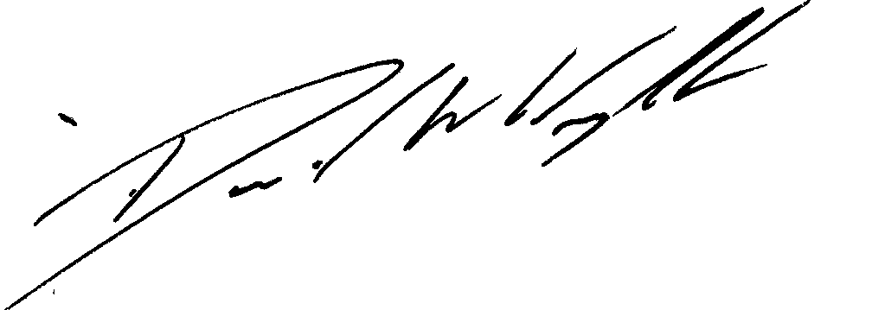

Clerk: D W Wright
The Garth
2 Broc Hill Way
Milford
Signed: Clerk Stafford, ST17 0UB
Tel: 01785 661182
6th September 2021 standonpcclerk@yahoo.co..uk
www.standonparish.org.uk

