NOTICE OF MEETING

STANDON PARISH COUNCIL

Annual Parish Council Meeting
All Saints School, Church, Lane,Standon
Monday 8th May 2017 – 7.45pm
or following the Annual Parish Assembly if later

AGENDA

- To elect a Chairman
- To receive the Chairman’s declaration of acceptance of office and agreement to abide by the Standon Parish Council Code of Conduct
- To appoint members to other committees
- To consider payment of annual subscriptions
- Community Council
- First Insurance
- To receive and consider any apologies for absence
- To receive any Declarations of Interest in accordance with Standon Parish Council Code of Conduct 2007
- Minutes: To approve the minutes of the meeting of 13th March 2017
- Planning
- To discuss current Planning Applications and confirm responses.
- Finance
- To receive and approve the Accounts for the Year ended 31st March 2017
- To approve the Statement of Accounts for submission to Audit.
- To receive a report on the Accounts for the year to date
- To approve accounts for payment

- Highways. Speed limit on A519, Cotes Heath
- Special Items
- Projects for the Parish
- To receive and consider items of correspondence
- Items raised by Councillors for information or inclusion on agenda for next meeting
- To confirm the Date and Venue of Next Parish Council Meeting.

The public and press are cordially invited to attend this meeting
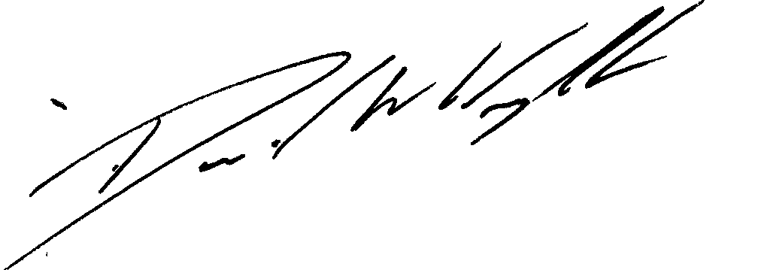

Clerk: D W Wright
The Garth
2 Broc Hill Way
Milford
Signed: Clerk Stafford, ST17 0UB
Tel: 01785 661182
30th April 2017 standonpcclerk@yahoo.co..uk

!!! Parish Website is live at www.standonparish.org.uk !!!

