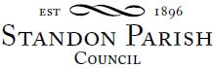

Annual Parish Council Meeting

!!This is a remote meeting on Zoom!!!
Monday 10th May 2021 – 7.45pm
or following the Annual Parish Assembly if later

AGENDA

- To elect a Chairman
- To receive the Chairman’s declaration of acceptance of office and agreement to abide by the Standon Parish Council Code of Conduct
- To report co-option of a Councillor
- To consider payment of annual subscriptions
- To receive and consider any apologies for absence
- To receive any Declarations of Interest in accordance with Standon Parish Council Code of Conduct
- Minutes: To approve the minutes of the meeting of 8th March 2021
- Planning
- To discuss current Planning Applications and confirm responses.
- Finance
- To receive and approve the Accounts for the Year ended 31st March 2021
- To approve the Certification of Exemption from Audit
- To approve the Annual Governance and Accounting Statements.
- To appoint an internal auditor
- To receive a report on the Accounts for the year to date
- To approve accounts for payment
- Special Items
- Projects for the Parish
- To receive and consider items of correspondence
- Items raised by Councillors for information or inclusion on the next agenda .
- To confirm the Date and Venue of Next Parish Council Meeting.

Monday 12th July 2021 7.30 pm at Cotes Heath & Standon Community Centre

This is a PUBLIC meeting and you are invited to attend.
The details for connecting on-line are below. https://us02web.zoom.us/j/83403313658?pwd=WW1aNTEyQUR2dWgzVXhXeVZpcm5EZz09

Meeting ID: 834 0331 3658 Passcode: 552382

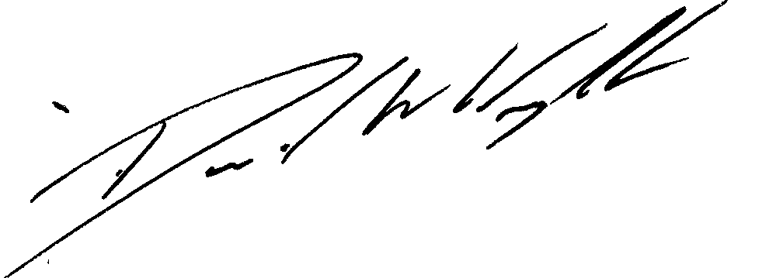

Clerk: D W Wright
The Garth
2 Broc Hill Way
Milford
Signed: Clerk Stafford, ST17 0UB
Tel: 01785 661182
3rd May 2021 standonpcclerk@yahoo.co..uk

