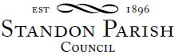
Annual Parish Council Meeting
All Saints School, Church Lane, Standon
Monday 16th May 2022 – 7.45pm
or following the Annual Parish Assembly if later

AGENDA

- To elect a Chairman
- To receive the Chairman’s declaration of acceptance of office and agreement to abide by the Standon Parish Council Code of Conduct
- To co-opt Councillors
- To consider payment of annual subscriptions
- SPCA
- Community Council
- First Insurance
- To receive and consider any apologies for absence
- To receive any Declarations of Interest in accordance with Standon Parish Council Code of Conduct
- Minutes: To approve the minutes of the meeting of 14th March 2022
- Planning
- To discuss current Planning Applications and confirm responses.
- Finance
- To receive and approve the Accounts for the Year ended 31st March 2022
- To approve the Certification of Exemption from Audit
- To approve the Annual Governance and Accounting Statements.
- To appoint an internal auditor
- To receive a report on the Accounts for the year to date
- To approve accounts for payment
- Special Items
- Projects for the Parish
- To receive and consider items of correspondence
- Items raised by Councillors for information or inclusion on agenda for next meeting
- To confirm the Date and Venue of Next Parish Council Meeting.

Monday 11th July 2022 7.30 pm at Cotes Heath & Standon Community Centre
The public and press are cordially invited to attend this meeting
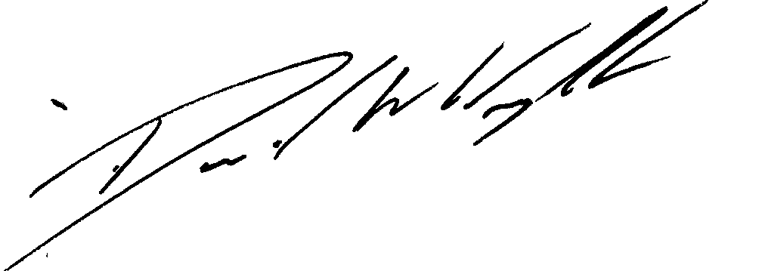

Clerk: D W Wright
The Garth
2 Broc Hill Way
Milford
Signed: Clerk Stafford, ST17 0UB
Tel: 01785 661182
1st May 2022 standonpcclerk@yahoo.co..uk

www.standonparish.org.uk

