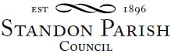

Parish Council Meeting
!!This is a remote meeting on Zoom!!!
Monday 9th November 2020 – 7.30pm

AGENDA

- Public session:

- To receive and consider any apologies for absence

- Co-option to fill a Casual Vacancy

- To receive any Declarations of Interest in accordance with Standon Parish Council Code of Conduct (2007)

- Minutes: To approve the minutes of the meeting of 14th September 2020 and consider matters arising.

- Highways - Footpaths

- Planning
- To report on Planning decisions
- To report on new Applications
- To discuss current Planning Applications and confirm responses.

- Finance
- To receive a report on the Accounts for the year to date
- To approve accounts for payment

- Special Items
- Parish Projects: Short and long term programme.

- To receive and consider items of correspondence

- Items raised by Councillors for information or inclusion on agenda for next meeting

To confirm the Date and Venue of Next Parish Council Meeting
Monday 11th January 2021 7.30 pm at All Saints School, Standon or if necessary remotely using Zoom

This is a PUBLIC meeting. The details for connecting on-line are given below.
https://us02web.zoom.us/j/83800110563?pwd=M2gxamFYTjZ2dzMrWnJtQW5VZmNQQT09
Meeting ID: 838 0011 0563 Passcode: 714559
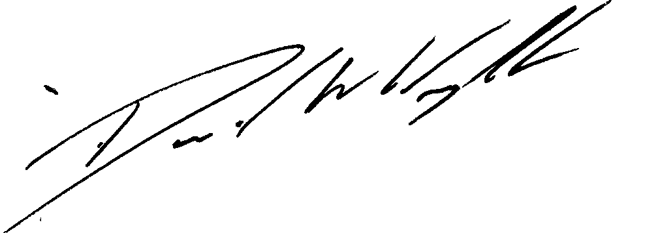

Clerk: D W Wright
The Garth
2 Broc Hill Way
Milford
Stafford, ST17 0UB
Signed: Clerk Tel: 01785 661182
2nd November 2020 standonpcclerk@yahoo.co..uk

